**HACKATHON DAY 1**

**Business Proposal: Biorunners - Marketplace-Driven E-Commerce for Biosciences based products and services.**

**Vision:**

As a graduate with two gold medals in Biotechnology, I recognize the potential and untapped talent within the life sciences field. The lack of adequate resources for biosciences field has fueled my vision to create a platform that serves as a bridge between academia and industry. **It is technology in my biology that inspires me.** Through Biorunners, I aim to empower the next generation of Bioscientists by providing them with access to digital solutions and fostering collaboration with industry leaders.

**Executive Summary:**

Biorunners aims to create a **Marketplace-Drive E-Commerce** platform focused on the niche of **life sciences equipment**, **research products**, and **educational services**. The platform's primary objective will be to offer **short-term rentals** of advanced tools and technologies essential for biosciences and life sciences research. By doing so, Biorunners seeks to bridge the divide between **academia** and **industry**, offer **IT courses** tailored for **biosciences students** in Pakistan, and equip students with the necessary resources to turn their innovative ideas into tangible applications. Through providing an **affordable and accessible rental model**, Biorunners will empower students, foster **sustainable research**, and give students' creations a chance to be seen by a global audience.

**Business Goals**

1. Bridge the Gap Between Academia and Industry.
2. Create a platform for students to rent equipment, collaborate with industry experts, and showcase their innovations.
3. Enable industries to discover emerging talent and research breakthroughs.
4. Promote a Sustainable Research Culture in Pakistan.
5. Provide affordable access to life sciences tools to encourage sustainable research practices.
6. Foster innovation while minimizing environmental resource consumption.
7. Showcase Student Products to the International Community.
8. Offer a platform for student-created research products to connect with global customers and partners.
9. Facilitate international exposure for student innovations.
10. Become the Largest E-Commerce Platform for Bioproducts and Research Products in Pakistan.
11. Establish Biorunners as the largest e-commerce platform in Pakistan, specializing in biotech and research products.
12. Provide a comprehensive range of products, equipment, and services to become the go-to platform for biotechnology and biosciences.
13. Enhance IT Education for Biosciences Students.
14. Offer specialized IT courses relevant to biosciences students to enhance their technical skills.
15. Provide learning resources and training in digital tools, software, and applications that are crucial for modern research and biotechnology.
16. Establish an idea bank for students to submit their research ideas and innovations.
17. Allow industry leaders and investors to access and collaborate on these ideas, fostering the development of cutting-edge technologies.

**Data Schema**

**[Product]**

ID: Unique identifier for the product.

Name: Name of the product.

Price: Price of the product.

Stock: Available stock quantity.

[**Order] → [Customer]**

Order ID: Unique identifier for the order.

Product ID: ID of the product being ordered.

Quantity: Number of units ordered.

**[Customer]**

**Contact Page**

Customer ID: Unique identifier for the customer.

Name: Customer's name.

Contact Info: Customer’s contact details (e.g., email, phone).

**[Delivery Zone] [Shipment]**

**Platform Used: ShipEngine**

Shipment ID: Unique identifier for the shipment.

Order ID: ID of the order being shipped.

Status: Current shipment status (e.g., Shipped, Delivered).

[Delivery Zone]

Zone Name: Name of the delivery zone (e.g., city, region).

Coverage Area: Geographical area covered by the zone.

Assigned Driver: Name/ID of the driver responsible for delivery.

**Services Offered by Biorunners**:

**Equipment Rental for Lifesciences:**

Description: Biorunners offers short-term rentals of advanced life sciences and biotechnology equipment, making high-quality tools accessible to students and researchers at affordable rates. This service eliminates the need for large capital investments and promotes cost-effective research.

Examples: PCR machines, microscopes, centrifuges, incubators, spectrophotometers.

**Industry Collaboration and Mentorship:**

Description: The platform connects students with industry professionals and organizations, providing opportunities for mentorship, internships, and collaborative research. This helps students gain practical insights, refine their projects, and build networks with industry leaders.

Examples: Online workshops, guest lectures, industry-led projects, collaboration opportunities.

Major Partner: Sindh Biotechnologists Association.

**IT Education for Biosciences Students:**

Description: Biorunners offers specialized IT courses designed to enhance the skills of biosciences students, focusing on essential tools and software used in biotechnology and life sciences. These courses help students develop valuable technical skills that bridge the gap between biology and technology.

Examples: Courses on bioinformatics, laboratory software, data science for biotechnology, and IT systems used in labs.

**Major partners:**

* **Sindh Biotechnologists Association (**[sindhbiotech.com](https://sindhbiotech.com/))
* **GIAIC Faculty**
* **The Green Insights**

**Target Audience for Biorunners:**

**Biosciences Students and Researchers:**

**Needs:** Affordable access to research equipment, IT courses, and international exposure.

**Why Biorunners?** Offers rental equipment, industry collaborations, and relevant IT training for enhanced research.

**Academic Institutions and Universities:**

**Needs:** Reliable platform for student resources, industry connections, and educational tools.

**Why Biorunners?** Bridges the gap between academia and industry with equipment rentals and collaboration opportunities.

**Biotech and Life Sciences Industry Professionals:**

**Needs:** Discover talent, access research breakthroughs, and source specialized products.

**Why Biorunners?** Connects industry professionals with student-created innovations and research.

**Entrepreneurs and Startups in Biotech:**

**Needs:** Access to equipment, a marketplace for products, and connection with investors.

**Why Biorunners?** Provides cost-effective rentals and exposure for new biotech ideas.

**Global Investors and Industry Partners:**

**Needs:** Discover promising research and products for investment or collaboration.

**Why Biorunners?** Facilitates connections between global investors and emerging talent.

**Government and NGOs:**

**Needs:** Support sustainable research and foster local innovation in biosciences.

**Why Biorunners?** Promotes sustainable practices and provides essential resources to students and researchers.

**HACKATHON DAY 2**

**Frontend Requirements:**

* Next JS
* React
* Tailblock/figma
* Tailwind CSS
* Clerk for login and Signup

**Essential Pages:**

* Home
* Header
* About/ Vision
* Herosection
* Footer
* Products
* Products’ Detailed Page (Wide Range of Bio-products)
* Products card page
* Add to Cart Page 🡪 Shipment

**Product Categories:**

* Biofertilizers
* Research Products
* Bioproducts

**Services**

* Basic Bioinformatic courses
* Python for Biologists
* Advanced Bioinformatics courses

**Services’ Detailed Page**

* Services’ card page
* Add to Cart Page 🡪 Shipment

**Contact**

Form 🡪Product Featuring Booking Details

Call for Partnership/ Collaboration

**Backend Requirements:**

* CMS (Sanity)
* Third Parties API
* Mock API (Mock API.Io)
* Shipment API (Shipengine/ Stripe)

**Deployment:** **Vercel.**

**Mock API Data Creation, Integration and Display for Product Details Page**

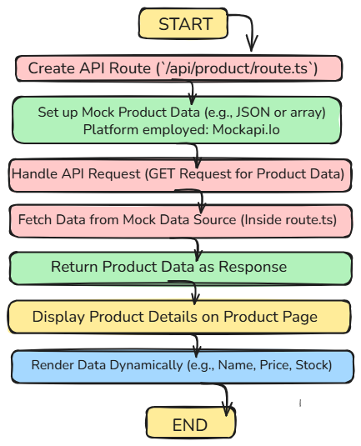

**Mock API Data in JSON Format**

[

{

"Name": "BioPower",

"Description": "Improves soil fertility and plant health by introducing beneficial microorganisms.",

"Price": 85,

"Availability": false,

"Supplier": "Local Distributor",

"Image": "https://img.hisupplier.com/var/userImages/2010-08/24/FertilizerDL_143549225_s.jpg",

"WebsiteLink": "Not available",

"id": "1",

"Category": "BioFertilizers"

},

{

"Name": "SoilPro Enhancer",

"Description": "Enhances nutrient uptake by plants with beneficial microbes.",

"Price": 100,

"Availability": true,

"Supplier": "AgriCo",

"Image": "https://th.bing.com/th/id/OIP.whfgYGaYObLbUFACTR1edgHaJ2?rs=1&pid=ImgDetMain",

"WebsiteLink": "https://agrico.com/soilpro",

"id": "2",

"Category": "BioFertilizers"

},

{

"Name": "EcoGro BioBoost",

"Description": "Promotes root growth and improves water retention in soil.",

"Price": 120,

"Availability": true,

"Supplier": "GreenGrow Supplies",

"Image": "https://th.bing.com/th/id/OIP.6_I_74pzRv_Qu-EdHsFH5QHaHa?rs=1&pid=ImgDetMain",

"WebsiteLink": "Not available",

"id": "3",

"Category": "BioFertilizers"

},

{

"Name": "GrowMate Plus",

"Description": "A sustainable solution for nitrogen fixation and improved soil quality.",

"Price": 90,

"Availability": true,

"Supplier": "GrowTech",

"Image": "https://th.bing.com/th/id/OIP.7-rZP71IRb0YydCEpywQAAHaHa?rs=1&pid=ImgDetMain",

"WebsiteLink": "https://growtech.pk/growmate",

"id": "4",

"Category": "BioFertilizers"

},

{

"Name": "AgroLife Bio",

"Description": "Improves soil fertility and plant resistance to diseases.",

"Price": 105,

"Availability": false,

"Supplier": "AgroLife",

"Image": "https://th.bing.com/th/id/OIP.oq1QwUOyar7FWDsGsGWTcQHaHa?rs=1&pid=ImgDetMain",

"WebsiteLink": "https://agrolife.com.pk",

"id": "5",

"Category": "BioFertilizers"

},

{

"Name": "NitroMax",

"Description": "Increases nitrogen fixation for higher crop yields.",

"Price": 115,

"Availability": true,

"Supplier": "AgriBoost",

"Image": "https://th.bing.com/th/id/OIP.9VonpMeAb_jJvuZdqvPrmgHaFe?rs=1&pid=ImgDetMain",

"WebsiteLink": "Not available",

"id": "6",

"Category": "BioFertilizers"

},

{

"Name": "RootShield Bio",

"Description": "Protects roots against harmful fungi and pathogens.",

"Price": 95,

"Availability": true,

"Supplier": "EcoRoots",

"Image": "https://th.bing.com/th/id/OIP.VaQYKMI1A1bFCdFLtKYQEwHaHa?rs=1&pid=ImgDetMain",

"WebsiteLink": "https://ecoroots.pk/rootshield",

"id": "7",

"Category": "BioFertilizers"

},

{

"Name": "GreenPulse",

"Description": "Stimulates plant growth and improves photosynthesis efficiency.",

"Price": 130,

"Availability": true,

"Supplier": "GreenPulse Solutions",

"Image": "https://biovante.com/wp-content/uploads/2022/03/Pulse-bottle-1.jpg",

"WebsiteLink": "Not available",

"id": "8",

"Category": "BioFertilizers"

},

{

"Name": "SoilGuard Plus",

"Description": "Prevents soil degradation and maintains fertility.",

"Price": 110,

"Availability": false,

"Supplier": "SoilGuard",

"Image": "https://naturesplusonline.com/wp-content/uploads/2024/09/Box-Mock-Soil-Guuard-front.jpg",

"WebsiteLink": "https://soilguard.com",

"id": "9",

"Category": "BioFertilizers"

},

{

"Name": "BioGold Fertilizer",

"Description": "Boosts soil nutrients with eco-friendly microbes.",

"Price": 125,

"Availability": true,

"Supplier": "EdgeGrow",

"Image": "https://th.bing.com/th/id/OIP.8e83c-ND44wndNASkz6cYAHaHR?rs=1&pid=ImgDetMain",

"WebsiteLink": "https://edgegrow.com",

"id": "10",

"Category": "BioFertilizers"

},

{

"Name": "SoilLife Pro",

"Description": "A premium biofertilizer that ensures balanced soil nutrients and long-term fertility.",

"Price": 120,

"Availability": true,

"Supplier": "SoilCare Industries",

"Image": "https://th.bing.com/th/id/OIP.bvzof20Qoh889pKm3BjpBQHaHa?rs=1&pid=ImgDetMain",

"WebsiteLink": "https://soilcare.pk",

"id": "11",

"Category": "BioFertilizers"

},

{

"Name": "PureSoil Enricher",

"Description": "Revitalizes depleted soils with essential nutrients and microorganisms, improving crop yield.",

"Price": 99,

"Availability": true,

"Supplier": "PureHarvest",

"Image": "https://5.imimg.com/data5/RP/NE/FE/SELLER-208914/soil-probiotics-bioculture-500x500.jpg",

"WebsiteLink": "https://pureharvest.com.pk",

"id": "12",

"Category": "BioFertilizers"

},

{

"Name": "Precision pH Meter",

"Description": "Highly accurate device for measuring pH levels in soil and solutions.",

"Price": 2500,

"Availability": true,

"Supplier": "LabTools",

"Image": "https://th.bing.com/th/id/OIP.45XSs693tZCsniRTK2ET2gHaG6?rs=1&pid=ImgDetMain",

"WebsiteLink": "https://labtools.pk/pH-meter",

"id": "13",

"Category": "ResearchEquipments"

},

{

"Name": "Digital Microscope",

"Description": "Advanced microscope with high-resolution imaging for research.",

"Price": 5000,

"Availability": false,

"Supplier": "TechLab Supplies",

"Image": "https://th.bing.com/th/id/OIP.3IjmNqKxSqNj5DADygHpvAHaHa?rs=1&pid=ImgDetMain",

"WebsiteLink": "https://techlab.com/microscope",

"id": "14",

"Category": "ResearchEquipments"

},

{

"Name": "Thermal Cycler",

"Description": "Essential tool for PCR and DNA amplification experiments.",

"Price": 7000,

"Availability": true,

"Supplier": "DNA Tools",

"Image": "https://th.bing.com/th?q=What+Is+a+Thermal+Cycler&w=120&h=120&c=1&rs=1&qlt=90&cb=1&pid=InlineBlock&mkt=en-WW&cc=PK&setlang=en&adlt=moderate&t=1&mw=247",

"WebsiteLink": "Not available",

"id": "15",

"Category": "ResearchEquipments"

},

{

"Name": "Spectrophotometer",

"Description": "Measures light intensity for quantitative analysis of samples.",

"Price": 6000,

"Availability": true,

"Supplier": "OptiLab",

"Image": "https://th.bing.com/th/id/R.b4ffac994405b8965b25088fc2be11ba?rik=mjYStFZupKPSMg&riu=http%3a%2f%2fwww.carolina.com%2fimages%2fproduct%2flarge%2f653323.jpg&ehk=5VCifEZb6m6hmibjZKDy0ulQwQDBpbO2p9ghs%2fndXcg%3d&risl=&pid=ImgRaw&r=0",

"id": "16",

"Category": "ResearchEquipments"

},

{

"Name": "Lab Centrifuge",

"Description": "Separates substances of varying densities with high-speed rotation.",

"Price": 4500,

"Availability": false,

"Supplier": "Lab Essentials",

"Image": "https://th.bing.com/th/id/OIP.5GxWwGau33qega12wWT1WQHaHa?rs=1&pid=ImgDetMain",

"WebsiteLink": "Not available",

"id": "17",

"Category": "ResearchEquipments"

},

{

"Name": "Analytical Balance",

"Description": "High-precision digital balance for accurate weighing in laboratory experiments.",

"Price": 250,

"Availability": true,

"Supplier": "PrecisionLab",

"Image": "https://infitek.com/wp-content/uploads/2021/06/0.0001g-Analytical-Balance-BA-P-Series8.jpg",

"WebsiteLink": "https://precisionlab.pk",

"id": "18",

"Category": "Research Equipments"

},

{

"Name": "Water Purification System",

"Description": "Advanced system for producing ultra-pure water for laboratory use.",

"Price": 1200,

"Availability": true,

"Supplier": "AquaLab Supplies",

"Image": "https://th.bing.com/th/id/OIP.2RG8sR9rFHnktZWcKvc2IwHaHa?w=176&h=180&c=7&r=0&o=5&pid=1.7",

"WebsiteLink": "https://aqualab.pk",

"id": "19",

"Category": "Research Equipments"

},

{

"Name": "Lab Oven",

"Description": "Reliable laboratory oven for drying, sterilizing, and general heating purposes.",

"Price": 890,

"Availability": true,

"Supplier": "ThermalTech Industries",

"Image": "https://th.bing.com/th/id/OIP.WghaoeTWg3kblfZlkLyW_AHaHe?w=172&h=180&c=7&r=0&o=5&pid=1.7",

"WebsiteLink": "https://thermaltech.pk",

"id": "20",

"Category": "Research Equipments"

},

{

"Name": "Organic Neem Oil",

"Description": "Natural pesticide for protecting crops from pests and fungi.",

"Price": 300,

"Availability": true,

"Supplier": "Nature's Care",

"Image": "https://th.bing.com/th/id/OIP.NffX2F7rwdp1XHL559zVfAHaHa?rs=1&pid=ImgDetMain",

"WebsiteLink": "https://naturescare.pk/neem-oil",

"id": "21",

"Category": "OrganicProducts"

},

{

"Name": "Compost Fertilizer",

"Description": "High-quality organic compost for improving soil health.",

"Price": 200,

"Availability": false,

"Supplier": "Green Earth",

"Image": "https://th.bing.com/th/id/OIP.1-QKTlJC40zgI-80ZHEuBAHaJu?rs=1&pid=ImgDetMain",

"WebsiteLink": "Not available",

"id": "22",

"Category": "OrganicProducts"

},

{

"Name": "Coconut Coir",

"Description": "Natural growing medium for better root support and moisture retention.",

"Price": 180,

"Availability": true,

"Supplier": "EcoGrowers",

"Image": "https://th.bing.com/th/id/R.9b8cce27fc42ac3eefde0a10efe4d976?rik=il1d%2fGpO77B%2bAA&pid=ImgRaw&r=0",

"WebsiteLink": "https://ecogrowers.com.pk",

"id": "23",

"Category": "OrganicProducts"

},

{

"Name": "Worm Castings",

"Description": "Nutrient-dense organic fertilizer produced by earthworms.",

"Price": 250,

"Availability": true,

"Supplier": "SoilRich Organics",

"Image": "https://th.bing.com/th/id/OIP.QAwnJPnIpmOVbTaq5dBpTAHaLJ?rs=1&pid=ImgDetMain",

"WebsiteLink": "Not available",

"id": "24",

"Category": "OrganicProducts"

},

{

"Name": "Seaweed Extract",

"Description": "Organic fertilizer derived from seaweed for healthy plant growth.",

"Price": 400,

"Availability": true,

"Supplier": "OceanGreen",

"Image": "https://www.legendagroindia.com/wp-content/uploads/2023/04/46.png",

"WebsiteLink": "https://oceangreen.com.pk",

"id": "25",

"Category": "OrganicProducts"

},

{

"Name": "Compost Tea Concentrate",

"Description": "Liquid organic fertilizer brewed from compost, rich in nutrients and microbes.",

"Price": 40,

"Availability": false,

"Supplier": "GreenCycle Organics",

"Image": "https://m.media-amazon.com/images/I/61Ww5w0AeDL.jpg",

"WebsiteLink": "https://greencycle.pk",

"id": "26",

"Category": "BioProducts"

},

{

"Name": "Lavender Essential Oil",

"Description": "A calming essential oil used for aromatherapy and natural insect repellents.",

"Price": 40,

"Availability": true,

"Supplier": "PureScents",

"Image": "https://th.bing.com/th/id/R.1dfaba6b4ab6e905cbaa100769295974?rik=I%2fG2dnAiF5vfVw&pid=ImgRaw&r=0",

"WebsiteLink": "https://purescents.pk",

"id": "27",

"Category": "BioOils"

},

{

"Name": "Tea Tree Oil",

"Description": "A powerful antiseptic oil that can be used for skincare, haircare, and insect repellent.",

"Price": 25,

"Availability": true,

"Supplier": "Nature's Essence",

"Image": "https://m.media-amazon.com/images/I/71dfFUKD+kL.jpg",

"WebsiteLink": "https://naturesessence.pk",

"id": "28",

"Category": "BioOils"

},

]

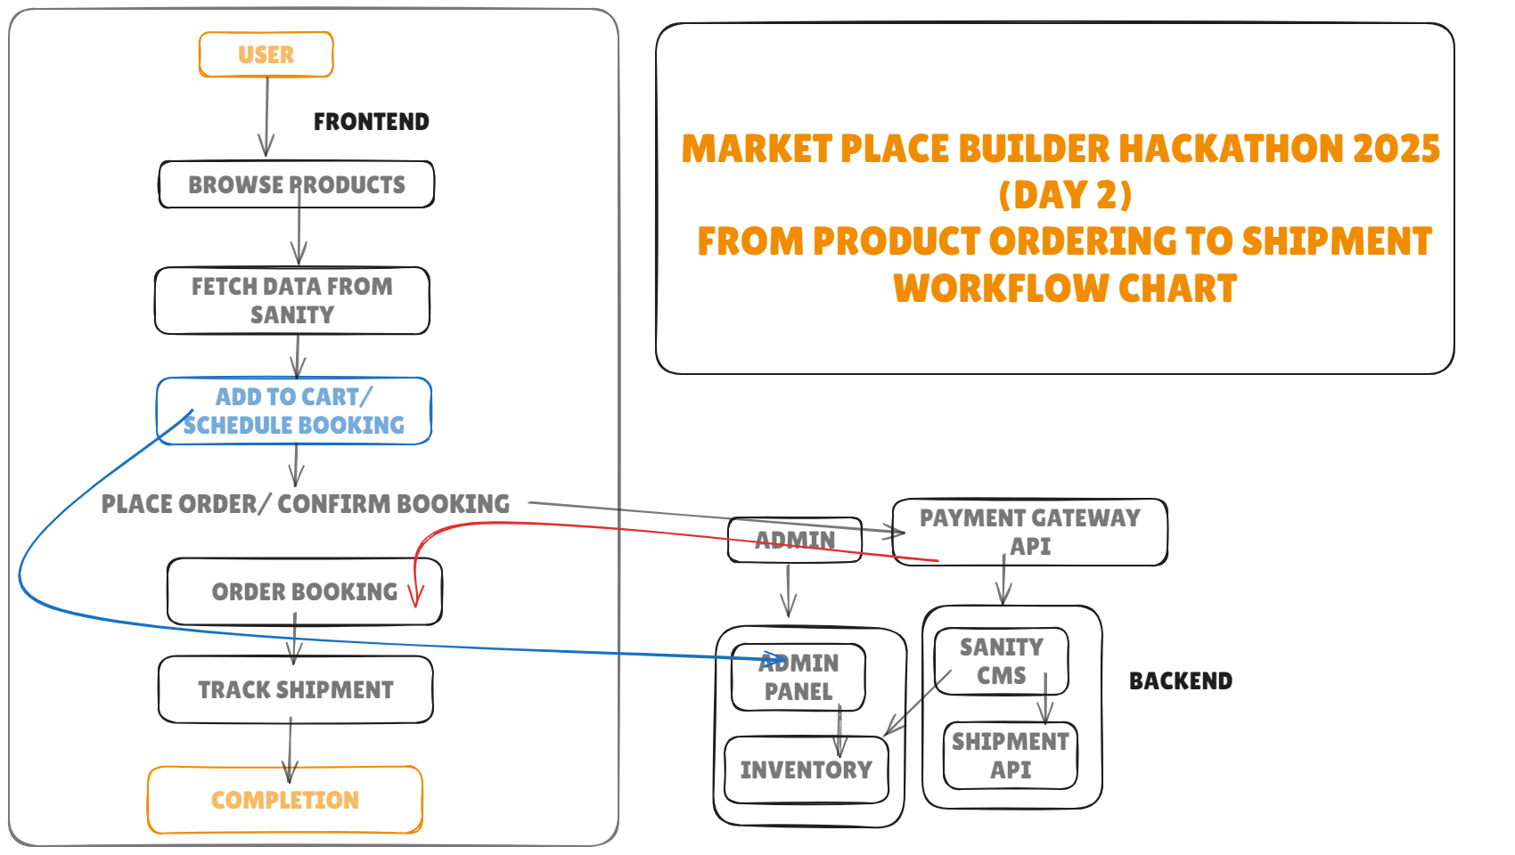

Fig: Technical Workflow chart

**HACKATHON DAY 3**

**API INTEGRATION PROCESS:**

**API Integration Process**

**Overview**  
The integration involved fetching product details from the API endpoint:  
<https://678fd35e49875e5a1a93828c.mockapi.io/Data>.

**Steps Followed**:

* Created a route.ts file in the api/product directory for routing purposes.
* Used the fetch API in the useEffect hook to retrieve data asynchronously.
* Error handling was implemented to catch network or response issues.

**API Data Handling**:

Data fetched from the API was verified for correct structure using TypeScript interfaces.

Products were categorized into three sections:

* **Biofertilizers**: First 10 items.
* **Research Equipment**: Items 11–15.
* **Bioproducts**: Remaining items.

Responsive layouts were applied for better UI/UX across devices.

**Tools & Libraries**:

* **React** and **Next.js** for frontend development.
* **Tailwind CSS** for styling.
* **TypeScript** for data type validation and interface definitions.
* **Mock API** for testing and development.

**Migration Steps and Tools Used**

**Migration Plan**:

* Data migration was limited to API consumption and frontend rendering.
* The fetched data was structured and categorized before rendering.

**Steps**:

* Created a TypeScript interface to validate API response structure.
* Rendered API data dynamically into categories (Biofertilizers, Research Equipment, Bioproducts).
* Designed UI components for responsiveness and modularity.

**Tools Used**:

* **Mock API** for testing data calls.
* **TypeScript** to enforce API schema compatibility.
* **Next.js dynamic routes** for detailed product pages.
* 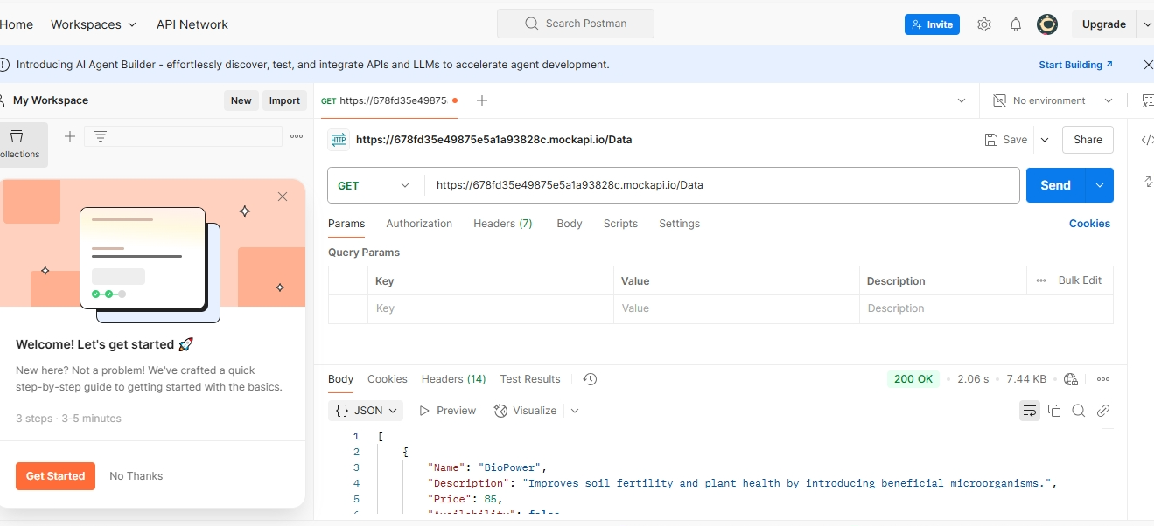**Postman** for "Successful API Call – 200 OK Response

This screenshot shows a successful API call made to the endpoint https://678fd35e49875e5a1a93828c.mockapi.io/Data using Postman. The response returned a status code of 200 OK, indicating that the request was processed successfully, and the data was retrieved.

**API INTEGRATION CODE:**

import { NextResponse } from "next/server";

export async function GET() {

  try {

    const response = await fetch("https://678fd35e49875e5a1a93828c.mockapi.io/Data");

    if (!response.ok) {

      throw new Error("Failed to fetch data from Fake Store API");

    }

    const products = await response.json();

    return NextResponse.json(products);

  } catch (error) {

    console.error("API Route Error:", error);

    return NextResponse.json({ error: "Failed to fetch products" }, { status: 500 });

  }

}

**PRODUCTS DETAILED PAGE** (Returning API Response)

**PRODUCTS’ DISPLAY ON BROWSER:**

**Marketplace Frontend Architecture Overview**

The following discussion provides a detailed overview of the key components and their interactions within the marketplace frontend. The architecture focuses on managing cart data, product exploration, dynamic routing, and the overall user experience, ensuring seamless navigation and interaction throughout the platform.

**1. CartContext (Cart/CartContext/page.tsx)**

**Purpose:** Manages the cart state (items, quantity, etc.) and provides functions like update quantity and remove from cart.

**Key Features**:

* Wraps the app with a context provider to make cart data accessible globally across the application.
* Handles the addition, removal, and updating of cart items.

**2. CartPage (Cart/cartPage.tsx)**

**Purpose:** Displays the items in the cart and allows users to update quantities or remove items.

**Key Features:**

* Uses the useCart hook to access and manage cart data.
* Provides users with options to update item quantities and remove items from the cart.

**3. CartRoute (Cart/page.tsx)**

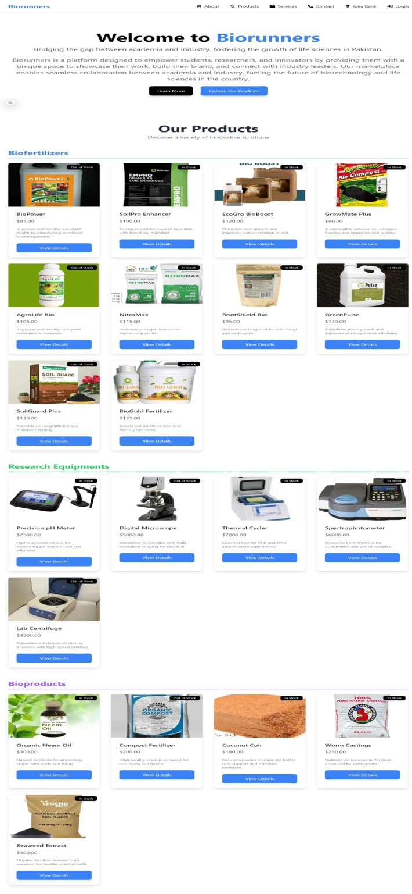**Purpose:** The wrapper route that links to the CartPage for cart-related functionality.

**Key Features:**

* Serves as the main entry point for cart functionality.
* Routes users to the CartPage.

**4. ProductDetails (Components/productDetails.tsx)**

Purpose: Displays detailed information about a specific product, including price, description, and images.

**Key Features:**

* Allows users to add the product to the cart.
* Displays detailed product specifications and images.

**5. Dynamic Product Page (app/products/[id]/page.tsx)**

**Purpose:** Uses dynamic routing to display product details based on the id in the URL.

**Key Features:**

* Fetches and displays product details using the dynamic product ID.
* Passes the product ID to the ProductDetails component for rendering the detailed information.

**Key Components for the Platform**

**Header**

**Purpose:** Contains navigation links (e.g., Home, Cart, Idea Bank, Courses, Contact) to facilitate smooth user navigation.

**Key Features:**

* Ensures consistent navigation across all pages.
* Positioned at the top for quick access to important sections.
* Can include logos, search bars, or icons to enhance functionality.

**Hero Section**

**Purpose:** A visually appealing introductory section, typically located at the top of the homepage.

**Key Features:**

* Includes brand vision.
* Directs users to explore products.

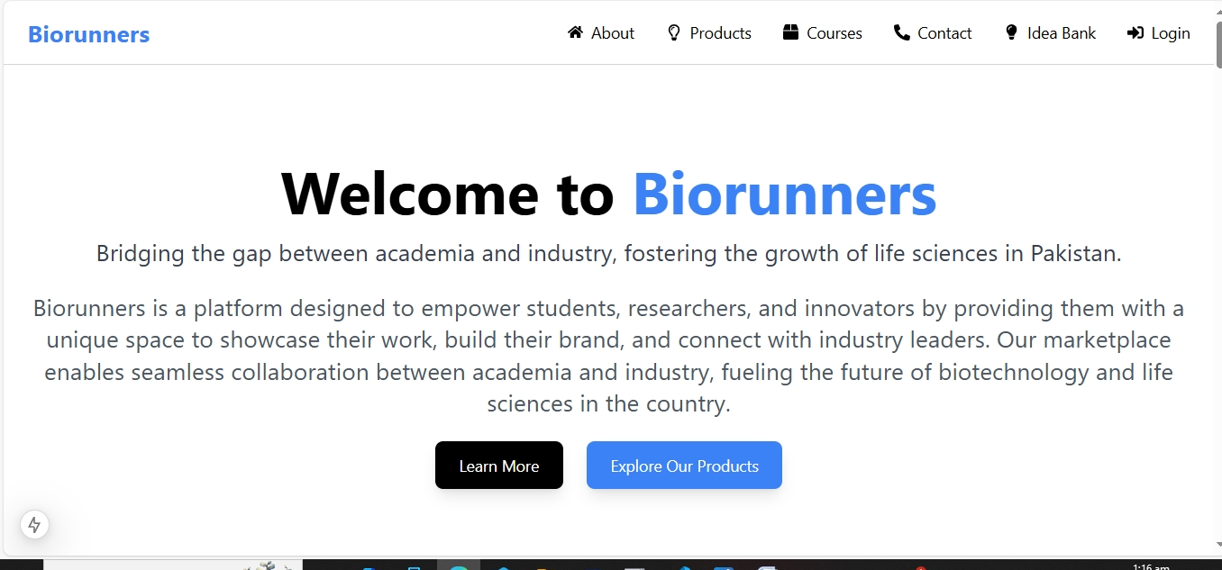

**Idea Bank**

**Purpose:** Displays a collection of ideas, innovations, or resources for users to explore or contribute to.

**Key Features:**

* Provides a place for users to view and add ideas.
* Can be structured as a gallery, list, or interactive platform.
* Often includes search or filter options for easier navigation.



Fig: Idea Bank

**Courses**

**Purpose:** A section dedicated to educational content, offering courses to users.

**Key Features:**

* Allows users to explore a variety of courses (e.g., Python for Biologists, Bioinformatics).
* Can include descriptions, prerequisites, pricing, and course details.
* Often includes a 'See More' button or direct links to detailed course pages

**Contact Page**

Purpose: Provides users with the means to get in touch with platform administrators.

**Key Features:**

* It provides contact details like name, email and phone numbers.
* It also provides course booking details to avail products’ featuring services.

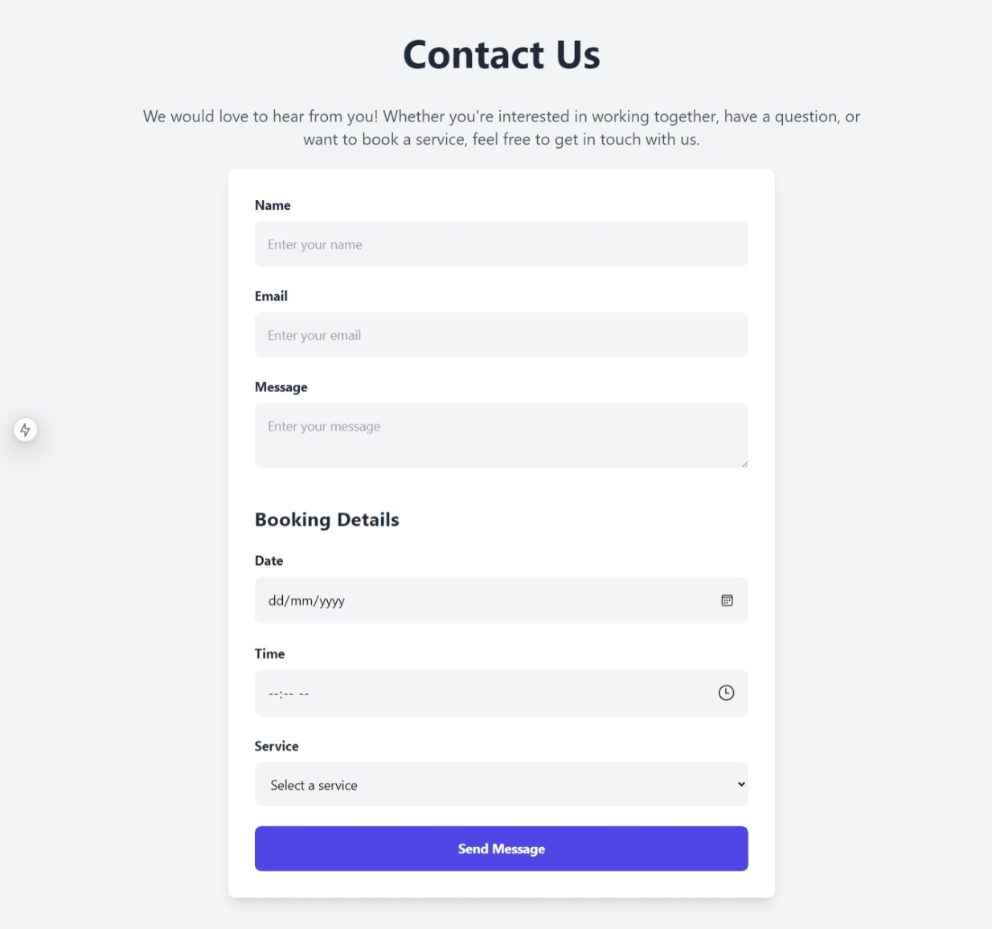

**Footer**

**Purpose:** Provides essential links and information at the bottom of the page.

**Key Features:**

* Includes links to Privacy Policy, Terms & Conditions, Contact info.
* Displays copyright and platform ownership details.
* Ensures easy access to legal and support information at all times.



Fig: Footer

**Hackathon day 4**

**ProductDetails (**Components/productDetails.tsx)

**Purpose:** Displays detailed information about a specific product, including price, description, and images.

import { useEffect, useState } from 'react';

import Link from 'next/link';

import Image from 'next/image';

interface Product {

  id: string;

  Name: string;

  Description: string;

  Price: number;

  Availability: boolean;

  Image: string;

}

export default function ProductDetails() {

  const [products, setProducts] = useState<Product[]>([]);

  const [error, setError] = useState<string>('');

  const [loading, setLoading] = useState<boolean>(true);

  useEffect(() => {

    const fetchProducts = async () => {

      try {

        const response = await fetch('https://678fd35e49875e5a1a93828c.mockapi.io/Data');

        if (!response.ok) {

          throw new Error(`Failed to fetch products: ${response.statusText}`);

        }

        const data: Product[] = await response.json();

        if (Array.isArray(data)) {

          setProducts(data);

        } else {

          throw new Error('Unexpected data format');

        }

      } catch (err: any) {

        setError(err.message);

      } finally {

        setLoading(false);

      }

    };

    fetchProducts();

  }, []);

  if (loading) {

    return (

      <div className="text-center text-gray-600">

        <svg

          className="animate-spin h-8 w-8 mx-auto text-blue-500"

          xmlns="http://www.w3.org/2000/svg"

          viewBox="0 0 24 24"

          fill="none"

          stroke="currentColor"

        >

          <circle cx="12" cy="12" r="10" strokeWidth="4" stroke="currentColor" fill="none"></circle>

          <path fill="none" stroke="currentColor" strokeWidth="4" d="M4 12a8 8 0 0 1 16 0"></path>

        </svg>

        <p className="mt-4">Loading products...</p>

      </div>

    );

  }

  if (error) {

    return <div className="text-center text-red-500 font-semibold">{`Error: ${error}`}</div>;

  }

  // Categorize products

  const bioFertilizers = products.slice(0, 10);

  const researchEquipments = products.slice(10, 15);

  const bioProducts = products.slice(15);

  return (

    <div className="max-w-7xl mx-auto px-6 py-12">

      <header className="text-center mb-12">

        <h1 className="text-5xl font-bold text-gray-800">Our Products</h1>

        <p className="text-xl text-gray-600 mt-2">Discover a variety of innovative solutions</p>

      </header>

      {/* Categories */}

      <section className="mb-16">

        <h2 className="text-3xl font-bold text-blue-500 mb-6 border-b-4 border-blue-300 pb-2">

          Biofertilizers

        </h2>

        <ul className="grid grid-cols-1 sm:grid-cols-2 md:grid-cols-3 lg:grid-cols-4 gap-8">

          {bioFertilizers.map((product) => (

            <ProductCard key={product.id} product={product} />

          ))}

        </ul>

      </section>

      <section className="mb-16">

        <h2 className="text-3xl font-bold text-green-500 mb-6 border-b-4 border-green-300 pb-2">

          Research Equipments

        </h2>

        <ul className="grid grid-cols-1 sm:grid-cols-2 md:grid-cols-3 lg:grid-cols-4 gap-8">

          {researchEquipments.map((product) => (

            <ProductCard key={product.id} product={product} />

          ))}

        </ul>

      </section>

      <section>

        <h2 className="text-3xl font-bold text-purple-500 mb-6 border-b-4 border-purple-300 pb-2">

          Bioproducts

        </h2>

        <ul className="grid grid-cols-1 sm:grid-cols-2 md:grid-cols-3 lg:grid-cols-4 gap-8">

          {bioProducts.map((product) => (

            <ProductCard key={product.id} product={product} />

          ))}

        </ul>

      </section>

    </div>

  );

}

// Product Card Component

function ProductCard({ product }: { product: Product }) {

  return (

    <li className="bg-white border rounded-lg shadow-lg overflow-hidden hover:shadow-xl transition-shadow duration-300">

      <div className="relative">

        <div className="w-full h-56 overflow-hidden">

          <Image

            src={product.Image}

            alt={product.Name || 'Product Image'}

            width={500}

            height={300}

            className="w-full h-full object-cover object-center"

          />

        </div>

        <div className="absolute top-2 right-2 bg-black text-white text-xs px-3 py-1 rounded-lg">

          {product.Availability ? 'In Stock' : 'Out of Stock'}

        </div>

      </div>

      <div className="p-6">

        <h3 className="text-xl font-semibold text-gray-800 mb-2">{product.Name || 'No Title'}</h3>

        <p className="text-lg text-gray-700 mb-4">${product.Price?.toFixed(2)}</p>

        <p className="text-sm text-gray-500 mb-6 line-clamp-3">

          {product.Description || 'No description available.'}

        </p>

        <Link href={`/products/${product.id}`} passHref>

          <button className="w-full bg-blue-500 text-white px-6 py-3 rounded-lg hover:bg-blue-600 transition-transform duration-300 transform hover:scale-105">

            View Details

          </button>

        </Link>

      </div>

    </li>

  );

}

**Dynamic Product Page (app/products/[id]/page.tsx)**

**Purpose:** Uses dynamic routing to display product details based on the id in the URL.

**Key Features:**

* Fetches and displays product details using the dynamic product ID.
* Passes the product ID to the ProductDetails component for rendering the detailed information.

import { useEffect, useState } from 'react';

import Link from 'next/link';

import Image from 'next/image';

interface Product {

  id: string;

  Name: string;

  Description: string;

  Price: number;

  Availability: boolean;

  Image: string;

}

export default function ProductDetails() {

  const [products, setProducts] = useState<Product[]>([]);

  const [error, setError] = useState<string>('');

  const [loading, setLoading] = useState<boolean>(true);

  useEffect(() => {

    const fetchProducts = async () => {

      try {

        const response = await fetch('https://678fd35e49875e5a1a93828c.mockapi.io/Data');

        if (!response.ok) {

          throw new Error(`Failed to fetch products: ${response.statusText}`);

        }

        const data: Product[] = await response.json();

        if (Array.isArray(data)) {

          setProducts(data);

        } else {

          throw new Error('Unexpected data format');

        }

      } catch (err: any) {

        setError(err.message);

      } finally {

        setLoading(false);

      }

    };

    fetchProducts();

  }, []);

  if (loading) {

    return (

      <div className="text-center text-gray-600">

        <svg

          className="animate-spin h-8 w-8 mx-auto text-blue-500"

          xmlns="http://www.w3.org/2000/svg"

          viewBox="0 0 24 24"

          fill="none"

          stroke="currentColor"

        >

          <circle cx="12" cy="12" r="10" strokeWidth="4" stroke="currentColor" fill="none"></circle>

          <path fill="none" stroke="currentColor" strokeWidth="4" d="M4 12a8 8 0 0 1 16 0"></path>

        </svg>

        <p className="mt-4">Loading products...</p>

      </div>

    );

  }

  if (error) {

    return <div className="text-center text-red-500 font-semibold">{`Error: ${error}`}</div>;

  }

  // Categorize products

  const bioFertilizers = products.slice(0, 10);

  const researchEquipments = products.slice(10, 15);

  const bioProducts = products.slice(15);

  return (

    <div className="max-w-7xl mx-auto px-6 py-12">

      <header className="text-center mb-12">

        <h1 className="text-5xl font-bold text-gray-800">Our Products</h1>

        <p className="text-xl text-gray-600 mt-2">Discover a variety of innovative solutions</p>

      </header>

      {/* Categories */}

      <section className="mb-16">

        <h2 className="text-3xl font-bold text-blue-500 mb-6 border-b-4 border-blue-300 pb-2">

          Biofertilizers

        </h2>

        <ul className="grid grid-cols-1 sm:grid-cols-2 md:grid-cols-3 lg:grid-cols-4 gap-8">

          {bioFertilizers.map((product) => (

            <ProductCard key={product.id} product={product} />

          ))}

        </ul>

      </section>

      <section className="mb-16">

        <h2 className="text-3xl font-bold text-green-500 mb-6 border-b-4 border-green-300 pb-2">

          Research Equipments

        </h2>

        <ul className="grid grid-cols-1 sm:grid-cols-2 md:grid-cols-3 lg:grid-cols-4 gap-8">

          {researchEquipments.map((product) => (

            <ProductCard key={product.id} product={product} />

          ))}

        </ul>

      </section>

      <section>

        <h2 className="text-3xl font-bold text-purple-500 mb-6 border-b-4 border-purple-300 pb-2">

          Bioproducts

        </h2>

        <ul className="grid grid-cols-1 sm:grid-cols-2 md:grid-cols-3 lg:grid-cols-4 gap-8">

          {bioProducts.map((product) => (

            <ProductCard key={product.id} product={product} />

          ))}

        </ul>

      </section>

    </div>

  );

}

// Product Card Component

function ProductCard({ product }: { product: Product }) {

  return (

    <li className="bg-white border rounded-lg shadow-lg overflow-hidden hover:shadow-xl transition-shadow duration-300">

      <div className="relative">

        <div className="w-full h-56 overflow-hidden">

          <Image

            src={product.Image}

            alt={product.Name || 'Product Image'}

            width={500}

            height={300}

            className="w-full h-full object-cover object-center"

          />

        </div>

        <div className="absolute top-2 right-2 bg-black text-white text-xs px-3 py-1 rounded-lg">

          {product.Availability ? 'In Stock' : 'Out of Stock'}

        </div>

      </div>

      <div className="p-6">

        <h3 className="text-xl font-semibold text-gray-800 mb-2">{product.Name || 'No Title'}</h3>

        <p className="text-lg text-gray-700 mb-4">${product.Price?.toFixed(2)}</p>

        <p className="text-sm text-gray-500 mb-6 line-clamp-3">

          {product.Description || 'No description available.'}

        </p>

        <Link href={`/products/${product.id}`} passHref>

          <button className="w-full bg-blue-500 text-white px-6 py-3 rounded-lg hover:bg-blue-600 transition-transform duration-300 transform hover:scale-105">

            View Details

          </button>

        </Link>

      </div>

    </li>

  );

}

.**CartRoute (Cart/page.tsx)**

**Purpose:** The wrapper route that links to the CartPage for cart-related functionality.

**Key Features:**

* Serves as the main entry point for cart functionality.
* Routes users to the CartPage.
* Since items are displayed in chunks with navigation controls, **pagination has been achieved.**

"use client";

import Image from "next/image";

import { useState } from "react";

import { useCart } from "../Cart/Context/Cartcontext";

const CartPage = () => {

  const { cart, updateQuantity, removeFromCart } = useCart();

  const [imageFallback, setImageFallback] = useState<string | null>(null); // State to handle image fallback

  // Calculate total price

  const calculateTotal = () =>

    cart.reduce((total, item) => total + item.price * item.quantity, 0);

  // Handle image error

  const handleImageError = () => {

    setImageFallback("/default-image.png"); // Set fallback image on error

  };

  return (

    <div className="p-6 bg-gray-100 min-h-screen">

      {/* Heading */}

      <h1 className="text-3xl font-bold text-center text-gray-900 mb-2">

        Shop with Biorunners

      </h1>

      <h2 className="text-lg text-center text-gray-600 mb-6">

        You’re just a click away from ordering your product

      </h2>

      {/* Customized Message for Customers */}

      <div className="bg-blue-100 text-blue-800 border border-white-300  p-4 text-center mb-8 shadow-sm">

        <p className="text-sm md:text-base font-medium">

          🌟 Thank you for shopping with us! Don’t forget to double-check your cart before checkout. We’re excited to deliver your products soon! 🎉

        </p>

      </div>

      {cart.length === 0 ? (

        <div className="text-center mt-6">

          <p className="text-lg text-gray-500 mb-4">Your cart is currently empty.</p>

          <button

            onClick={() => window.location.href = "/Components/Productdisplay"} // Or wherever your product page is

            className="px-6 py-2 bg-blue-600 text-white rounded hover:bg-blue-700"

          >

            Start Shopping

          </button>

        </div>

      ) : (

        <div className="space-y-6 max-w-3xl mx-auto">

          {cart.map((item) => (

            <div

              key={item.id}

              className="flex flex-col md:flex-row justify-center items-center gap-6 border border-gray-300 bg-white p-6 rounded-lg shadow-md hover:shadow-lg transition-shadow"

            >

              {/* Left Section: Item Details */}

              <div className="text-center md:text-left">

                <h2 className="font-medium text-lg text-gray-800">

                  {item.heading}

                </h2>

                <p className="text-gray-600 mt-1">

                  ${item.price.toFixed(2)} x {item.quantity}

                </p>

                <p className="font-bold text-gray-800 mt-1">

                  Total: ${(item.price * item.quantity).toFixed(2)}

                </p>

                <p className="mt-3 text-sm text-gray-600">

                  <strong>Color:</strong> {item.selectedColor || "Not selected"}

                </p>

                <p className="text-sm text-gray-600">

                  <strong>Size:</strong> {item.selectedSize || "Not selected"}

                </p>

                <div className="flex items-center justify-center md:justify-start mt-4 space-x-3">

                  <button

                    onClick={() => updateQuantity(item.id, item.quantity - 1)}

                    className="px-2 py-1 bg-gray-100 border border-gray-300 rounded hover:bg-gray-200 text-sm transition"

                    aria-label="Decrease quantity"

                    disabled={item.quantity <= 1}

                  >

                    -

                  </button>

                  <span className="text-sm font-medium">{item.quantity}</span>

                  <button

                    onClick={() => updateQuantity(item.id, item.quantity + 1)}

                    className="px-2 py-1 bg-gray-100 border border-gray-300 rounded hover:bg-gray-200 text-sm transition"

                    aria-label="Increase quantity"

                  >

                    +

                  </button>

                </div>

                <div className="mt-3 flex space-x-3">

                  <button

                    onClick={() => removeFromCart(item.id)}

                    className="px-3 py-1 text-sm bg-red-500 text-white rounded hover:bg-red-600 transition"

                    aria-label="Remove item from cart"

                  >

                    Remove

                  </button>

                  <button

                    onClick={() => window.location.href = "/Components/Productdisplay"} // Navigate to the product display page

                    className="px-3 py-1 text-sm bg-green-500 text-white rounded hover:bg-green-600 transition"

                    aria-label="Add more products"

                  >

                    Add More Products

                  </button>

                  <button

                    onClick={() => {

                      cart.forEach(item => removeFromCart(item.id));

                    }}

                    className="px-3 py-1 text-sm bg-yellow-500 text-white rounded hover:bg-yellow-600 transition"

                    aria-label="Empty cart"

                  >

                    Empty Cart

                  </button>

                </div>

              </div>

              {/* Right Section: Item Image */}

              <div>

                <Image

                  src={imageFallback || item.image || "/default-image.png"}

                  alt={item.heading}

                  width={150}

                  height={150}

                  className="object-cover rounded-md shadow-sm"

                  onError={handleImageError} // Set fallback image on error

                />

              </div>

            </div>

          ))}

          {/* Bottom Section: Checkout */}

          <div className="flex justify-between items-center mt-9">

            {/* Back to Products Button */}

            <button

              onClick={() => window.history.back()} // Simple back functionality

              className="w-full md:w-auto px-6 py-2 bg-gray-600 text-white text-sm rounded hover:bg-gray-700 transition mt-11"

            >

              Back to Products

            </button>

            {/* Checkout Section */}

            <div className="flex flex-col items-end">

              <p className="mb-4 text-gray-800 font-bold text-lg">

                Total: ${calculateTotal().toFixed(2)}

              </p>

              <button className="w-full md:w-auto px-6 py-2 bg-blue-600 text-white text-sm rounded hover:bg-blue-700 transition">

                Proceed to Checkout

              </button>

            </div>

          </div>

        </div>

      )}

    </div>

  );

};

export default CartPage;

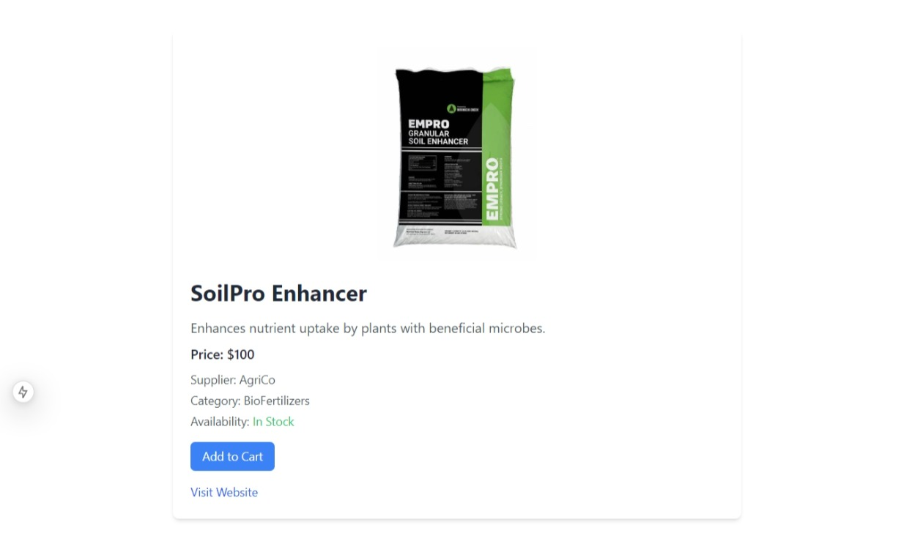

Product description page achieved through dynamic routing

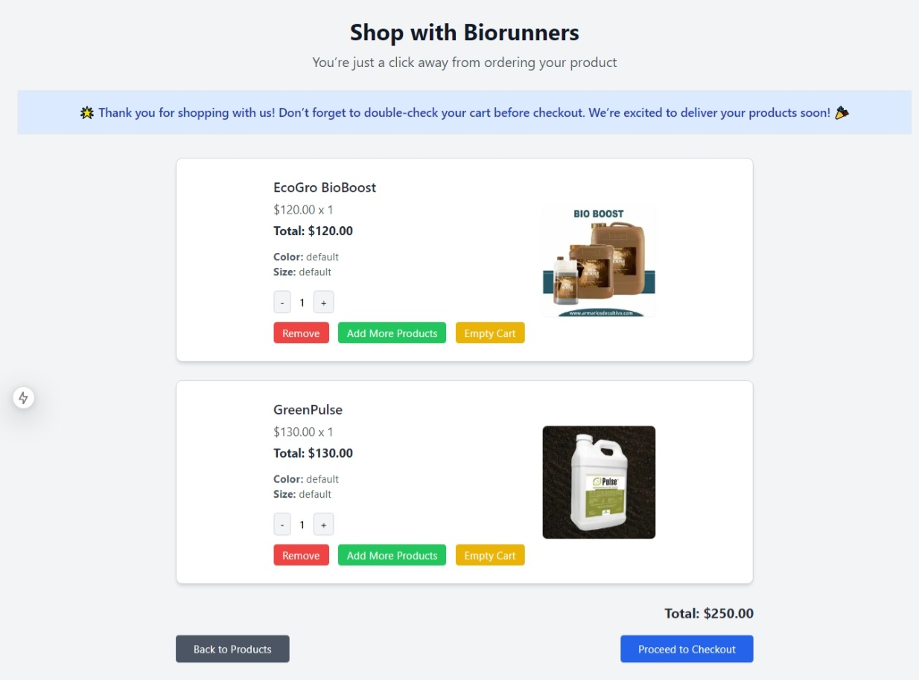

Fig: Add to Cart Button opens to Add to functional Add to Cart Page:

**Day 5 - Testing and Backend Refinement - [BIORUNNERS]**

**Functional Deliverables:**

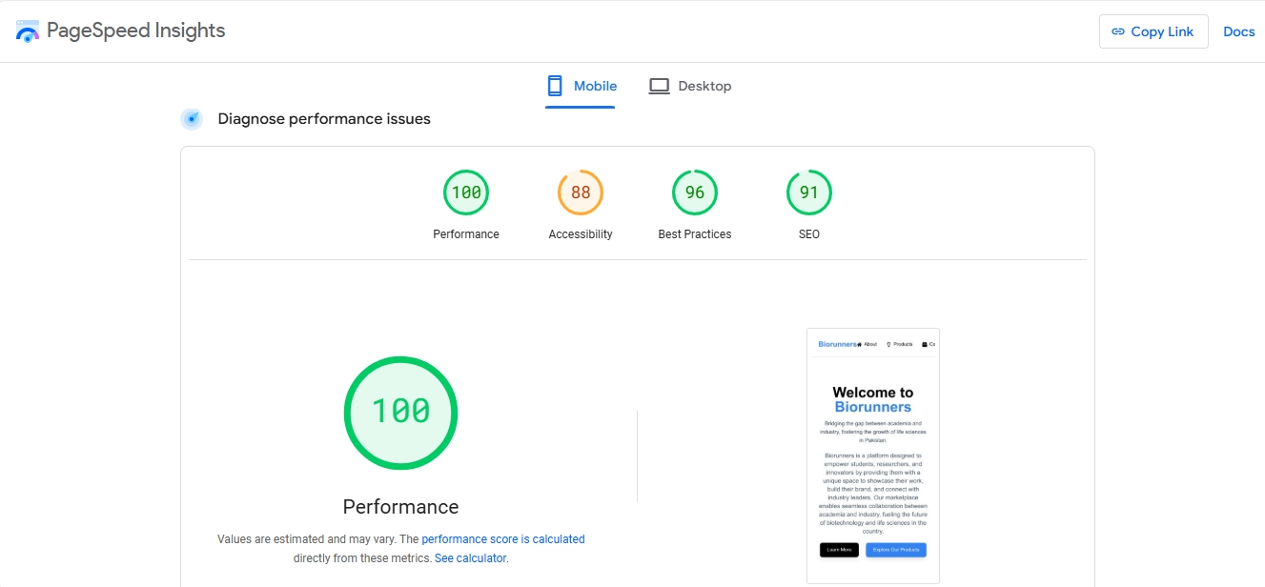

Fig: Diagnosis of performance issues by Lighthouse

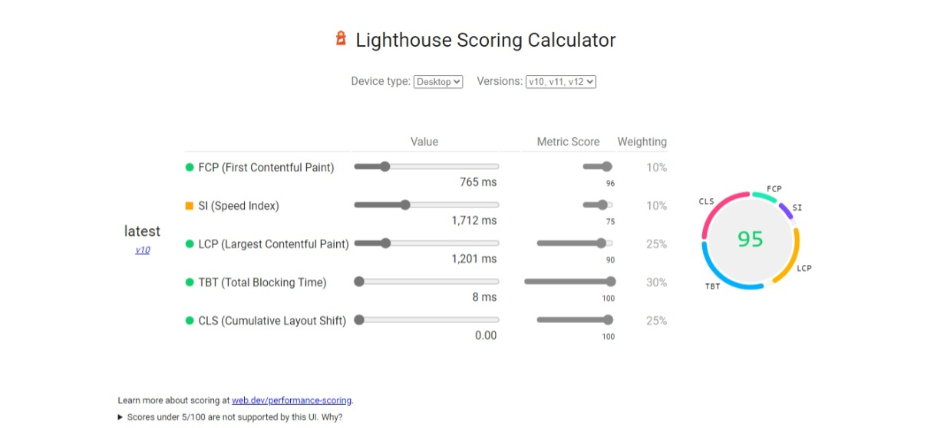

Fig: Lighthouse Scoring calculator for Mobile.



Fig: Lighthouse Scoring calculator for Dekstop.

**TESTING REPORT CSV**

|  |  |  |  |  |  |  |  |  |
| --- | --- | --- | --- | --- | --- | --- | --- | --- |
| 1 | **Test Case ID** | **Test Case Description** | **Test Steps** | **Expected Result** | **Actual**  **Result** | **Status** | **Severity Level** | **Remarks** |
| 2 | TC001 | Validate product listing page | Open product page > Verify products | Products displayed correctly | Products displayed correctly | passed | Low | No issue found in product display |
| 3 | TC002 | Test API error handling | Server error in fetching | Show fallback UI with error message | Error message pops up( No product found) | Passed | Medium | Handled successfuly |
| 4 | TC003 | Check cart functionality | Add product to cart > Verify cart contents | Cart updates with added product | Cart updates as expected | Passed | Medium | Works as expected |
| 5 | TC004 | Ensure responsiveness on mobile | Resize browser window > Check layout | Layout adjusts properly to screen size | Responsive layout working as intended | Passed | Medium | Test successful |

**Hackathon Day 6**

**Staging environment deployed Link.**

[Create Next App (my-biorunners.vercel.app)](https://my-biorunners.vercel.app/)